Time

import time
def c_to_f(c):
return c*9/5 + 32
t0 = time.clock()
c_to_f(100000)
t1 = time.clock() –t0
print("t = ", t1, "s, ")

Operations

def c_to_f(c):
return c*9/5 + 32

def mysum(x):
total = 0
for I in range(x+1):
total += 1
return total

Inputs

def search_for_elmt(L, e):
for i in L:
if i == e:
return True
return False

https://www.youtube.com/watch?v=RJhZ5SD1AvY
Types of Growth

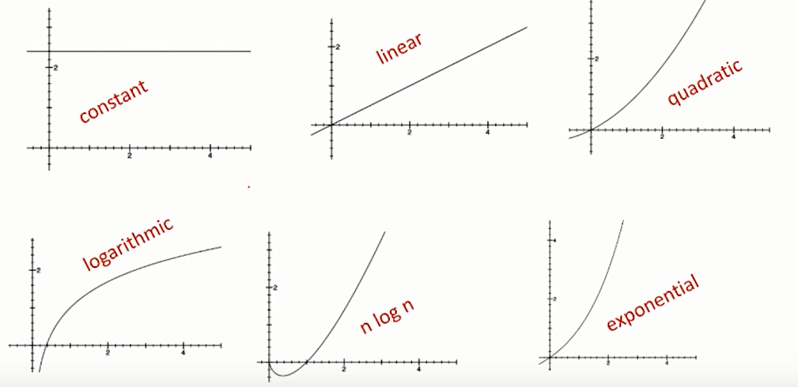

Big O Notation
Measures an upper bound on the asymptotic growth, also called order of growth

def fact_iter(n):
"""assumes n is an int >= 0"""
answer = 1
while n>1:
answer *= n
n -= 1
return answer

: n² + 2n + 2
: n² + 100000n + 3¹⁰⁰⁰
: log(n) + n + 4
: 0.0001*n*log(n) + 300n
: 2n³⁰ + 3^{n}
Exercises
def linearSearch(L, x):
for e in L:
if e == x:
return True
return False

Choose which of the following inputs to linearSearch would give the best case, average case, or worst case run time.

- Best Case Run Time
linearSearch([14, 15, 6, 27, 13, 16, 25, 11, 7], 15)
linearSearch([21, 1, 25, 22, 30, 13, 7, 24, 12], 24)
linearSearch([20, 10, 1, 7, 4, 22, 25, 12, 31], 20)
linearSearch([9, 3, 12, 24, 7, 8, 23, 11, 19], 8)
linearSearch([4, 12, 20, 17, 9, 14, 7, 24, 6], 7)
linearSearch([13, 9, 22, 3, 10, 17, 11, 2, 12], 26)

- Worst Case Run Time
linearSearch([14, 15, 6, 27, 13, 16, 25, 11, 7], 15)
linearSearch([21, 1, 25, 22, 30, 13, 7, 24, 12], 24)
linearSearch([20, 10, 1, 7, 4, 22, 25, 12, 31], 20)
linearSearch([9, 3, 12, 24, 7, 8, 23, 11, 19], 8)
linearSearch([4, 12, 20, 17, 9, 14, 7, 24, 6], 7)
linearSearch([13, 9, 22, 3, 10, 17, 11, 2, 12], 26)

- Average Case Run Time
linearSearch([14, 15, 6, 27, 13, 16, 25, 11, 7], 15)
linearSearch([21, 1, 25, 22, 30, 13, 7, 24, 12], 24)
linearSearch([20, 10, 1, 7, 4, 22, 25, 12, 31], 20)
linearSearch([9, 3, 12, 24, 7, 8, 23, 11, 19], 8)
linearSearch([4, 12, 20, 17, 9, 14, 7, 24, 6], 7)
linearSearch([13, 9, 22, 3, 10, 17, 11, 2, 12], 26)

- What is the number of steps it will take to run linearSearch in the best case? Express your answer in terms of n, the number of elements in the list L.
Indicate addition and multiplication explicitly, with + and * symbols. Indicate exponentiation with the caret (^) symbol.

- What is the number of steps it will take to run linearSearch in the worst case? Express your answer in terms of n, the number of elements in the list L.
Indicate addition and multiplication explicitly, with + and * symbols. Indicate exponentiation with the caret (^) symbol.

